Day 23 - 02nd Aug 2025

JUNIT testcases - atleast one or two if working pla raise your hands.

TASK 01

Tags Annotation:

import org.junit.jupiter.api.Test;

import org.junit.jupiter.api.Tags;

import org.junit.jupiter.api.Assertions.assertEquals;

class TestCase02 {

@Test

@Tags("firstPriority")

void testMethod01() {

}

@Test

@Tag("firstPriority")

void runTestcase02() {

}

@Tags("fastTag")

void testMethod03() {

}

@Test

@Tag("slowTag")

void runTestcase04() {

}

}

package lib;

import org.junit.jupiter.api.Test;

import org.junit.jupiter.api.Tag;

import static org.junit.jupiter.api.Assertions.*assertEquals*;

class TestCase02 {

@Test

@Tag("firstPriority")

void testMethod01() {

int expected = 2;

int actual = 1 + 1;

*assertEquals*(expected, actual);

}

@Test

@Tag("firstPriority")

void runTestcase02() {

String str = "JUnit";

*assertEquals*("JUnit", str);

}

@Test

@Tag("fastTag")

void testMethod03() {

*assertEquals*(4, 2 * 2);

}

@Test

@Tag("slowTag")

void runTestcase04() {

*assertEquals*(10, 5 + 5);

}

}

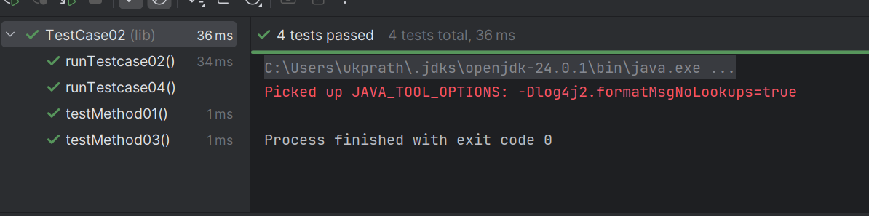

—----------------------------------------------------------------------------------------------------------------------

**Design patters:**

1. Creational Design Patterns:

types of Creational design Patterns:

1. Factory Method
2. Singleton Method
3. Abstract Factory Method
4. Builder Method
5. Prototype Method

**Factory Method Design Pattern**

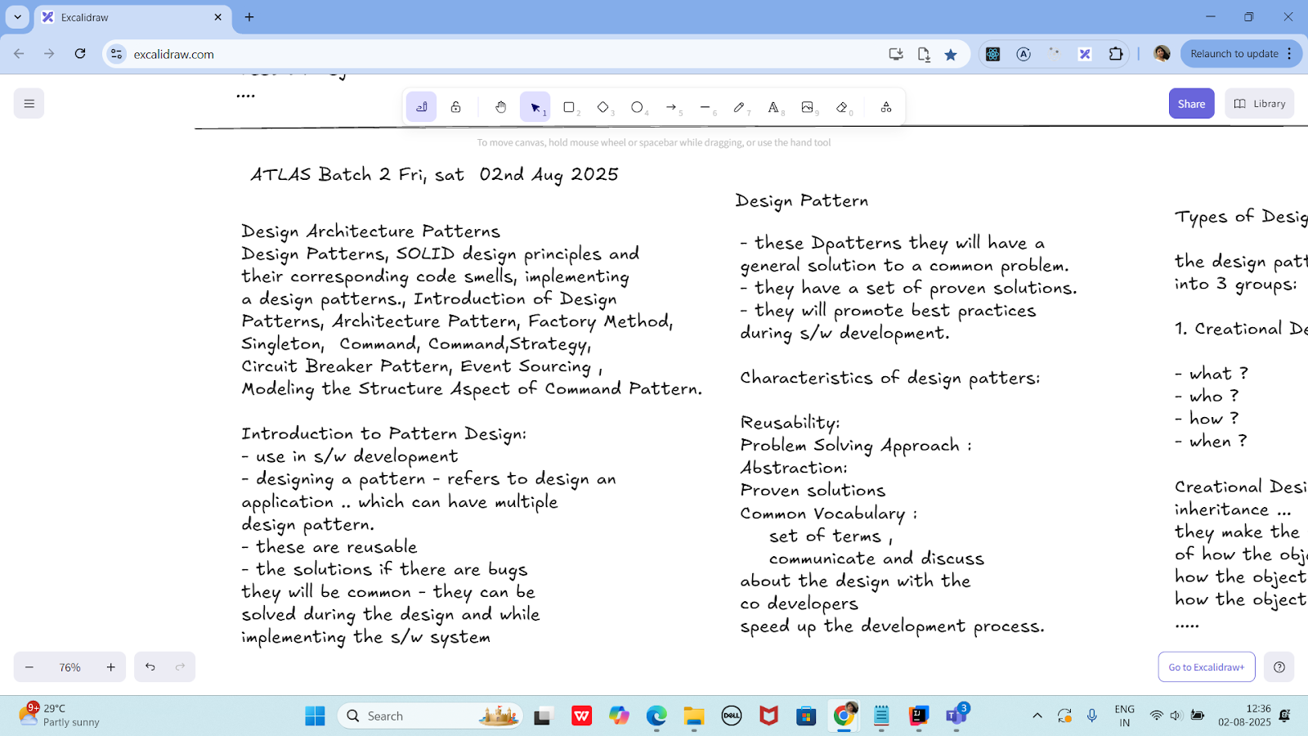

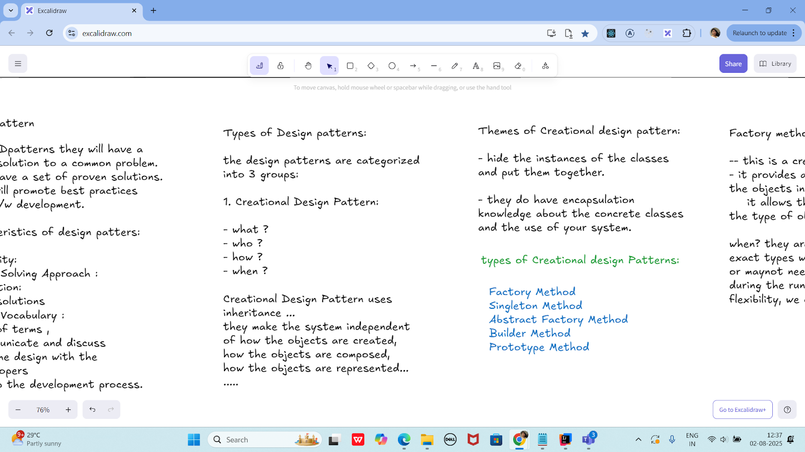

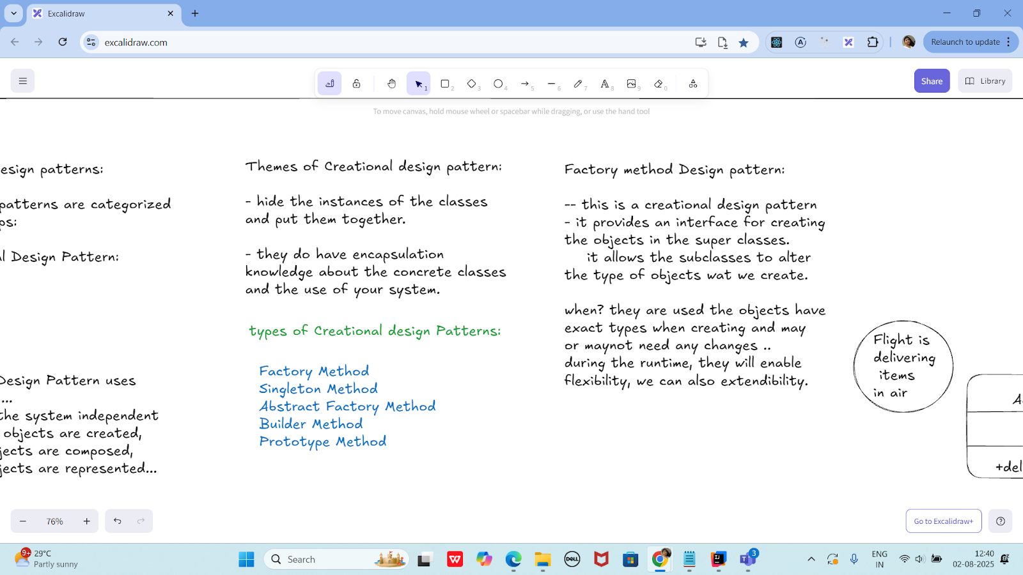

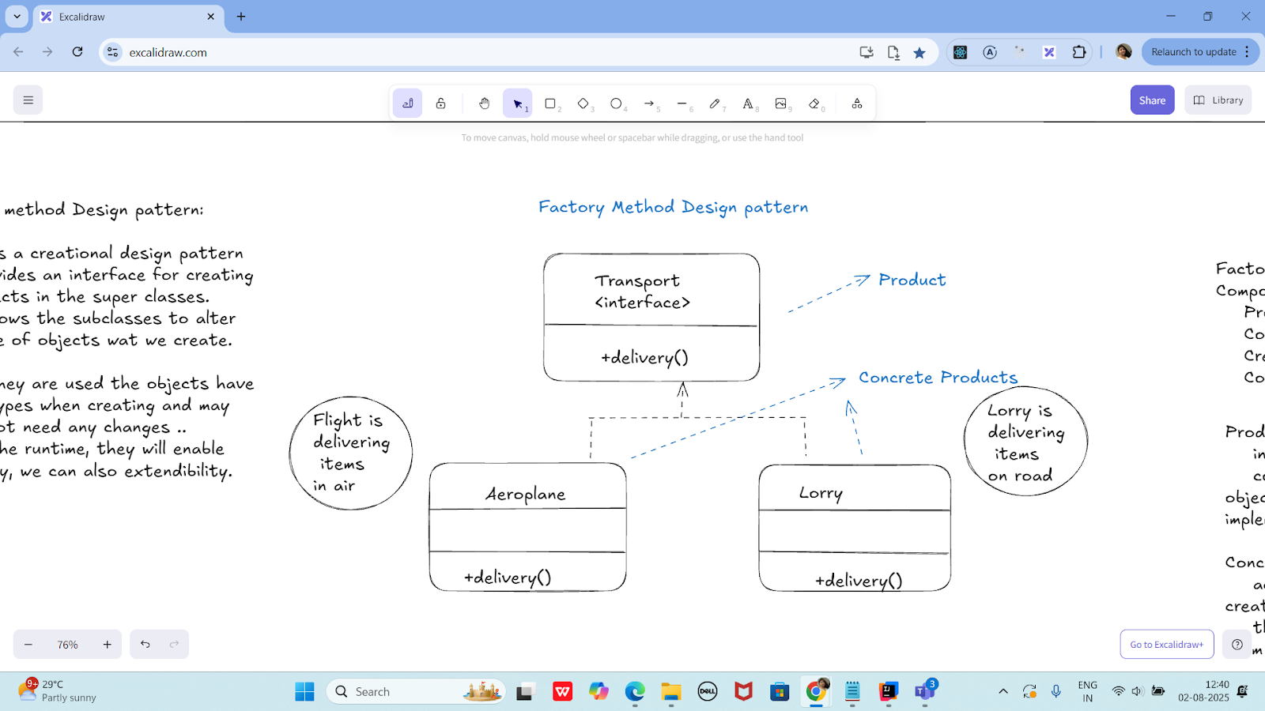

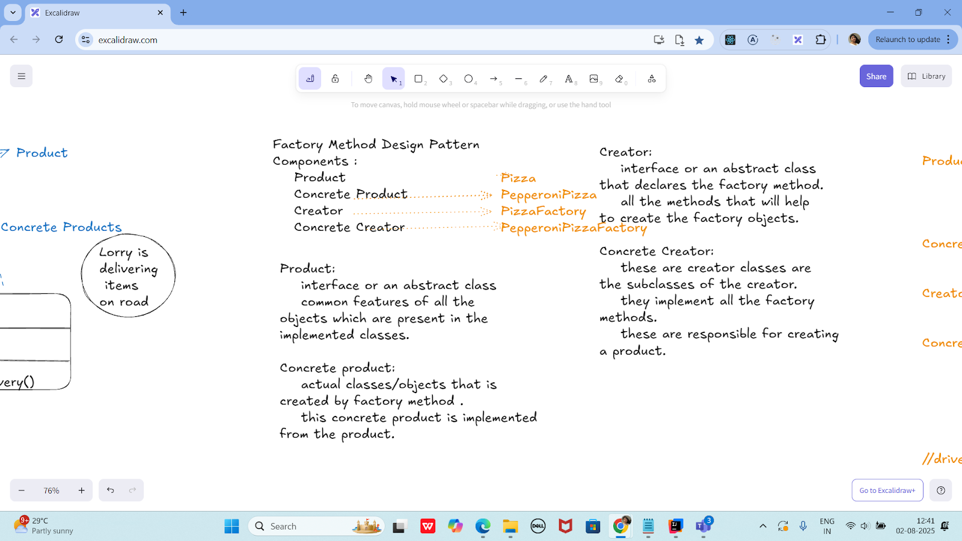

Product :-> Pizza interface/abstract class

preparation();

baking();

cutting();

boxing();

ConcreteProduct --> PepperoniPizza

//implement all the features of Pizza.

Creator ---> PizzaFactory interface/abstract class

Pizza createPizza(); - type is Pizza

Concretecreator ---> PepperoniPizzaFactory

@Override

Pizza createPizza() {

....

retrun new PepperoniPizza();

}

//driver class

class Sams {

psvm() {

PizzaFactory pfobj = new PepperoniPizzaFactory();

Pizza pobj = pfobj.createPizza();

}

}

public abstract class Pizza {

public abstract void preparation();

public abstract void baking();

public abstract void cutting();

public abstract void boxing();

}

public class PepperoniPizza extends Pizza {

@Override

public void preparation() {

System.*out*.println("Preparing pepperoni toppings and dough.");

}

@Override

public void baking() {

System.*out*.println("Baking pepperoni pizza at 350 degrees.");

}

@Override

public void cutting() {

System.*out*.println("Cutting pepperoni pizza into slices.");

}

@Override

public void boxing() {

System.*out*.println("Boxing pepperoni pizza in official box.");

}

}

public abstract class PizzaFactory {

public abstract Pizza createPizza();

}

public class PepperoniPizzaFactory extends PizzaFactory {

@Override

public Pizza createPizza() {

System.*out*.println("Creating a PepperoniPizza via factory...");

return new PepperoniPizza();

}

}

public class Sams {

public static void main(String[] args) {

PizzaFactory pfobj = new PepperoniPizzaFactory();

Pizza pobj = pfobj.createPizza();

pobj.preparation();

pobj.baking();

pobj.cutting();

pobj.boxing();

}

}

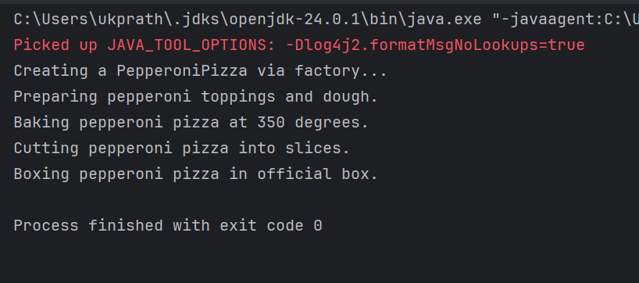

Singleton Method Design principle

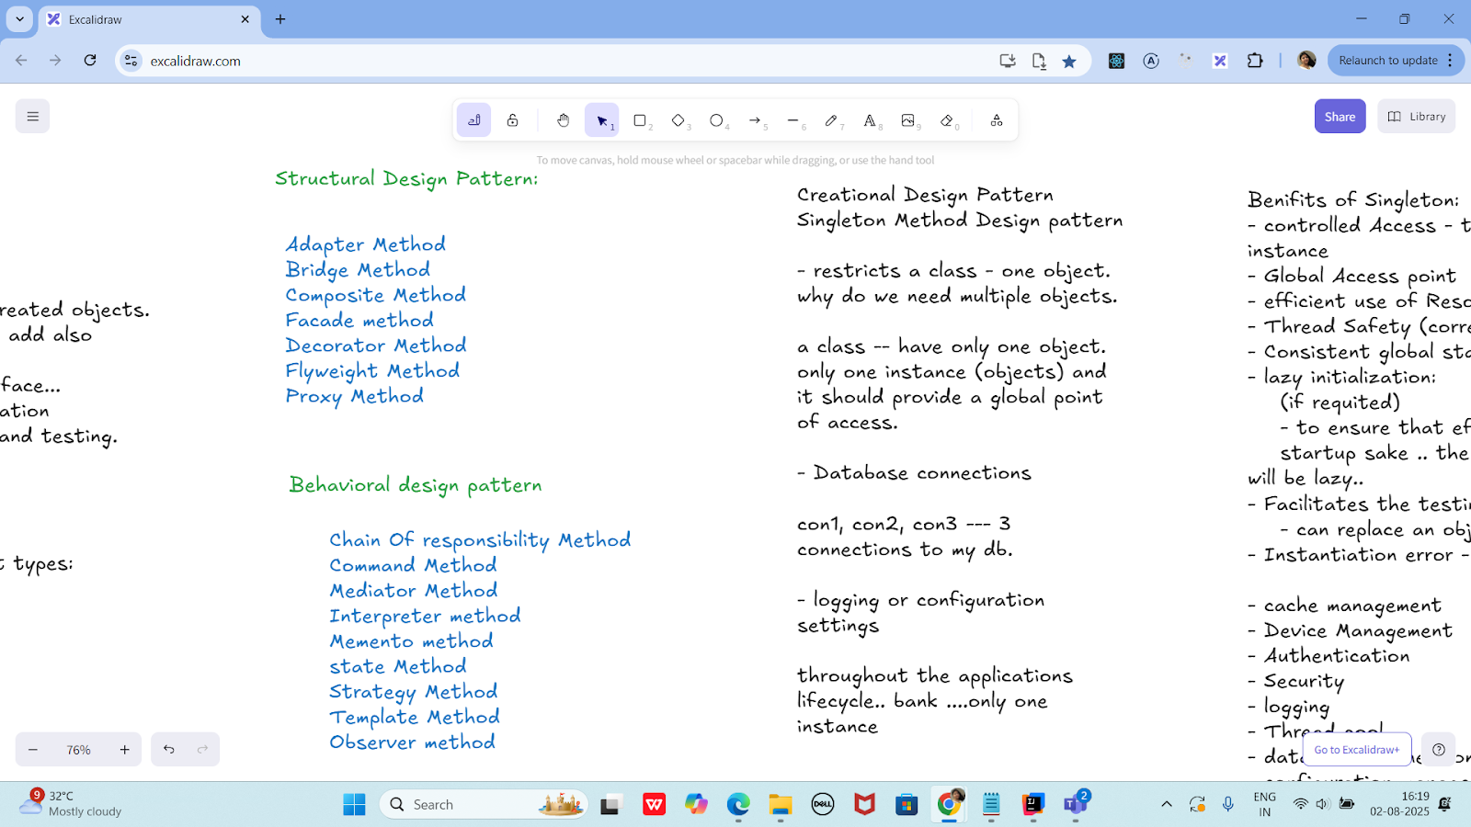

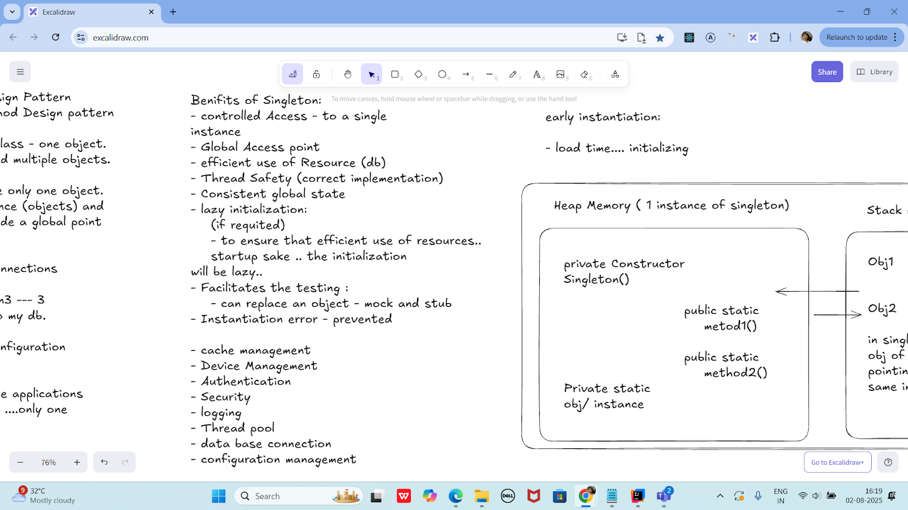

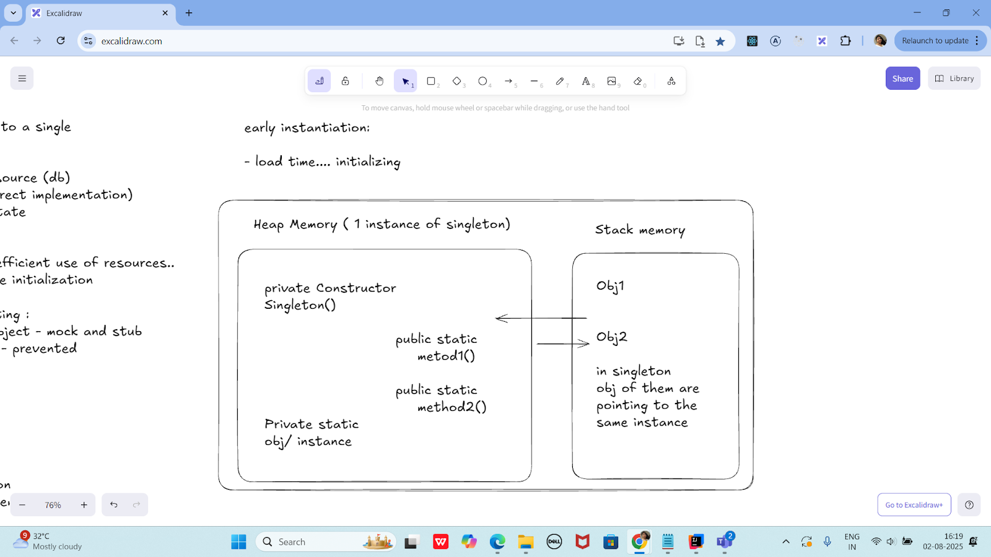

class SingletonDemo {

private static SingletonDemo *instance*; // lodinids.. //pass/ pin no

private SingletonDemo() {

System.*out*.println("initiating the singleton");

}

public static SingletonDemo getInstance() {

if (*instance* == null) {

*instance* = new SingletonDemo();

System.*out*.println("in get instance");

}

return *instance*;

}

public static void doHere() {

System.*out*.println("doing here some thing");

}

}

public class SingletonDP {

public static void main(String[] args) {

SingletonDemo.*getInstance*().*doHere*();

// SingletonDemo obj = new SingletonDemo();

// obj.doHere();

// SingletonDemo obj2 = new SingletonDemo();

// obj2.doHere();

}

}

—----------------------------------------------------------------------------------------------------------------------------------

—----------------------------------------------------------------------------------------------------------------------------------

Home Tasks:

Home Task 1:

Write a test case for the below java file

public class Junit4Test {

public int compare(int n1, int n2) {

if (n1 > n2) return 1;

return -1;

}

}

import org.junit.Test;

import static org.junit.Assert.*assertEquals*;

public class Junit4TestTest {

@Test

public void testCompare_WhenFirstIsGreater() {

Junit4Test obj = new Junit4Test();

int result = obj.compare(10, 5);

*assertEquals*(1, result);

}

@Test

public void testCompare_WhenSecondIsGreater() {

Junit4Test obj = new Junit4Test();

int result = obj.compare(3, 8);

*assertEquals*(-1, result);

}

@Test

public void testCompare_WhenEqual() {

Junit4Test obj = new Junit4Test();

int result = obj.compare(7, 7);

*assertEquals*(-1, result); // Because your logic returns -1 even if both are equal

}

}

**Home task 2:**

public int compare(int n1, int n2) {

if (n1 > n2) return 1;

else if (n1 < n2) return -1;

return 0;

}

public class CompareUtil {

public int compare(int n1, int n2) {

if (n1 > n2) return 1;

else if (n1 < n2) return -1;

return 0;

}

}

import org.junit.Test;

import static org.junit.Assert.*assertEquals*;

public class CompareUtilTest {

CompareUtil obj = new CompareUtil();

@Test

public void testCompare_FirstGreater() {

*assertEquals*(1, obj.compare(10, 5));

}

@Test

public void testCompare_SecondGreater() {

*assertEquals*(-1, obj.compare(4, 9));

}

@Test

public void testCompare_BothEqual() {

*assertEquals*(0, obj.compare(7, 7));

}

}

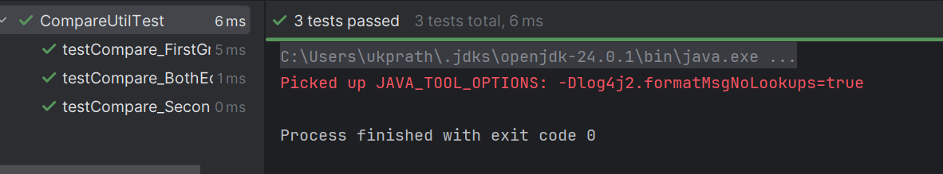

Hoe Task 3:

Include a test case and run the test suite.

Test Suite:

- its a bundle of unit test cases and run them

all together.

@Suite

@RunWith

TestSuite Demo

import org.junit.runner.RunWith;

import org.junit.runners.Suite;

@RunWith(Suite.class)

@Suite.SuiteClasses( {

JunitTest01.class,

JunitTest02.class,

JunitTest03.class

})

public class TestSuiteDemo {

}

JunitTest01.java

import org,junit.Test;

import static org.junit.Assert.assetEquals;

import org.junit.Igore;

public class junitTest01 {

String msg = "running test01 ";

MessageUtil msgUtilobj = new MessageUtil(msg);

//MessageUtil is a utility class

//store a message

@Test

public void msgTest() {

sout("we are inside the msgtest()");

assertEquals(msg, msgUtilobj.printMessage());

}

}

junitTest02.java

test Runner

public class MessageUtil {

private String message;

public MessageUtil(String message) {

this.message = message;

}

public String printMessage() {

return message;

}

}

import org.junit.Test;

import static org.junit.Assert.*assertEquals*;

public class JunitTest1 {

String msg = "running test01 ";

MessageUtil msgUtilobj = new MessageUtil(msg);

@Test

public void msgTest() {

System.*out*.println("Inside msgTest()");

*assertEquals*(msg, msgUtilobj.printMessage());

}

}

import org.junit.Test;

import static org.junit.Assert.*assertEquals*;

public class JunitTest2 {

String msg = "running test02 ";

MessageUtil msgUtilobj = new MessageUtil(msg);

@Test

public void msgTest() {

System.*out*.println("Inside JunitTest02 msgTest()");

*assertEquals*(msg, msgUtilobj.printMessage());

}

}

import org.junit.Test;

import static org.junit.Assert.*assertEquals*;

public class JunitTest3 {

String msg = "running test03 ";

MessageUtil msgUtilobj = new MessageUtil(msg);

@Test

public void msgTest() {

System.*out*.println("Inside JunitTest03 msgTest()");

*assertEquals*(msg, msgUtilobj.printMessage());

}

}

import org.junit.runner.RunWith;

import org.junit.runners.Suite;

@RunWith(Suite.class)

@Suite.SuiteClasses({

JunitTest1.class,

JunitTest2.class,

JunitTest3.class

})

public class TestSuiteDemo {

// No code needed here — just grouping tests

}

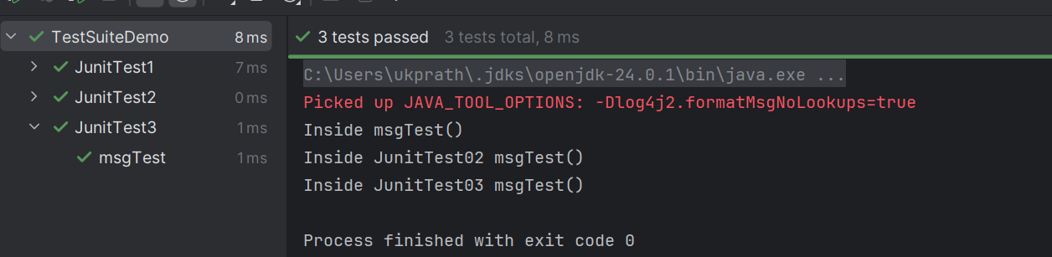

Home Task 4:

Implement the above code also add one more test case and test runner.. And execute the test suite.

================================================================================================================================================

**Info Box**

================================================================================================================================================

Info Box (Carry forward from Day 22 02nd Aug juz fyi..

Plz refer Best Programming Practices - Doc 08 in Docs to study

Updated link at 12.17 ..

<https://excalidraw.com/#json=lKmZDbhZ5V6ZRlQ3zJOXv,K6r0FziLUTf3htjdUrnN4w>

Updated link at 15.57

<https://excalidraw.com/#json=Mp0F2MJiO57HKm74LVHXK,XmhQybYlqAswiHdRIeokDQ>

Junit dependency

<https://junit.org/junit4/dependency-info.html>

<dependencies >

<dependency>

<groupId>junit</groupId>

<artifactId>junit</artifactId>

<version>4.13.2</version>

</dependency>

</dependencies >

The above dependency you need to add in the dependencies tag of pom.xml..

Junit Official link

Download

Hamcrest and Junit.jar file

<https://junit.org/>

Or add the below dependency

<dependency>

<groupId>org.junit.jupiter</groupId>

<artifactId>junit-jupiter-api</artifactId>

<version>6.0.0-M2</version>

</dependency>

Hamcrest dependency

<!-- https://mvnrepository.com/artifact/org.hamcrest/hamcrest-junit -->

<dependency>

<groupId>org.hamcrest</groupId>

<artifactId>hamcrest-junit</artifactId>

<version>2.0.0.0</version>

<scope>test</scope>

</dependency>

JUNIT Jupiter api - junit.jar file link

<https://mvnrepository.com/artifact/org.junit.jupiter/junit-jupiter-api>

Junit Hancrest

<https://mvnrepository.com/artifact/org.hamcrest/hamcrest>

Exclidraw - updated link at 12.33..

[https://excalidraw.com/#jso=cY4X2JOrLIvswxiToAxLB,01GKPhOFi8r3tEbo8hLCbw](https://excalidraw.com/#json=cY4X2JOrLIvswxiToAxLB,01GKPhOFi8r3tEbo8hLCbw)

Excalidraw - updated link at 16.20

<https://excalidraw.com/#json=udpoNQTqmw4D3clX_tr_9,w7du3hqQcDaDyG7PGsZtzw>

Codes for reference link → for uml codes

<https://drive.google.com/drive/folders/1LwhNov1s1-vHzF9GPAObLSnP9kAvipmw?usp=sharing>

Plz go through uml diagrams in page nos:

Docs 04 OOAD UML in doc to study

8 to 16

12

18 to 39

57 to 58

97

118

123

136

154 to 160

Plantuml site juz found .. plz check for reference

<https://plantuml.com/use-case-diagram>

================================================================================================================================================